In this project, I have designed a database management system to store the logistics and data about the packaged items that a shipment company will ship around the world. The data can be used by both the shipment company and the users seamlessly to gather required information. This database will contain the sender’s and receiver’s details once he/she plans on sending an item to be shipped such asname, email, address, etc. This will be helpful in case of an item being returned back to the sender. We also store the dimensions of the package which will help us in determining the cost of the shipment considering other factors like mode of shipment. This management system proves useful as we have assigned unique IDs to every relation such as OrderID, BillingID, etc. The sender can feel more connected to the package as he will have access to live tracking of the package. With the relationships present in this database management system, we can gather essential data required quickly and also update data wherever necessary. In the end, billing is taken care of as we care for every user who plans on using this database.

Table of Contents

 1. Tables

2. ER Model Assumptions

3. Functional Dependencies and Primary Keys

4. Normalization

5. Relationship Schema

 6. ER Diagram

7. SQL Code

**Tables**

1.Sender Table Stores details about the person sending the package.

|  |  |  |
| --- | --- | --- |
| ATTRIBUTE | DATATYPE | CONSTRAINTS |
| UserID | NUMBER | PRIMARY KEY |
| Name | VARCHAR2(30) | NOT NULL |
| Email | VARCHAR2(30) | NOT NULL |
| Phone no | NUMBER | NOT NULL |
| Address | VARCHAR2(30) | NOT NULL |
| City | VARCHAR2(30) | NOT NULL |
| Country | VARCHAR2(30) | NOT NULL |

2. Package Table Stores details about the package itself.

|  |  |  |
| --- | --- | --- |
| ATTRIBUTE | DATATYPE | CONSTRAINTS |
| UserID | NUMBER | FOREIGN KEY |
| ReceiverID | NUMBER | FOREIGN KEY |
| TransportID | NUMBER | FOREIGN KEY |
| OrderID | NUMBER | PRIMARY KEY |
| DateReceived | DATE | NOT NULL |
| DeliveryDate | DATE | NOT NULL |
| Weight | NUMBER(5,2) | NOT NULL |

3. Delivery Table Stores details about the costs associated with different shipping options.

|  |  |  |
| --- | --- | --- |
| ATTRIBUTE | DATATYPE | CONSTRAINTS |
| TransportID | NUMBER | PRIMARY KEY |
| TransportMethod | VARCHAR2(20) | NOT NULL |
| CostPerUnit | NUMBER | NOT NULL |

4. Billing Table Stores details about the final cost.

|  |  |  |
| --- | --- | --- |
| ATTRIBUTE | DATATYPE | CONSTRAINTS |
| OrderID | NUMBER | FOREIGN KEY |
| TransactionID | NUMBER | PRIMARY KEY |
| Description | VARCHAR(40) | NOT NULL |
| Cost | NUMBER | NOT NULL |

5. Tracking Table Stores details about the tracking of the package.

|  |  |  |
| --- | --- | --- |
| ATTRIBUTE | DATATYPE | CONSTRAINTS |
| OrderID | NUMBER | FOREIGN KEY |
| TrackingID | NUMBER | PRIMARY KEY |
| Origin | VARCHAR2(30) | NOT NULL |
| Current Location | VARCHAR2(30) | NOT NULL |
| Destination | VARCHAR2(30) | NOT NULL |
| Date | DATE | NOT NULL |

6. Receiver Table Stores details about the person receiving the package.

|  |  |  |
| --- | --- | --- |
| ATTRIBUTE | DATATYPE | CONSTRAINTS |
| ReceiverID | NUMBER | PRIMARY KEY |
| Name | VARCHAR2(30) | NOT NULL |
| Phone | VARCHAR2(30) | NOT NULL |
| Address | VARCHAR2(30) | NOT NULL |
| City | VARCHAR2(30) | NOT NULL |
| Country | VARCHAR2(30) | NOT NULL |

**ER Model Assumptions**

● A sender can send multiple packages to multiple receivers and is uniquely identified by his/her sender ID.

● Each package can be sent to only one receiver but a receiver can receive multiple packages and is identified by his/her receiver ID.

● Packages store information such as date of order, delivery date and weight which is uniquely identified by their Order ID.

● The sender can prefer his own method of delivery which associates each package to a Transport ID that can determine the cost per unit of the package and allows multiple senders to have the same Transport ID.

● Each package will finally have its own bill that stores its total cost of transportation along with a unique Transaction ID.

● After shipping the packages, they can also be tracked by the company’s servers which are recognized by its Tracking ID that can identify its current location.

**Functional Dependencies and Primary Keys**

1. Sender UserID -> {Name,Email,Phone,Address,City,Country} Since all fields depend on UserID, (UserID)+ -> R Hence, UserID is the Primary Key.

2. Package OrderID -> {UserID, ReceiverID, TransportID, Weight, DateReceived, DeliveryDate} Since all the fields depend on OrderID, (OrderID)+ -> R. Hence, OrderID is the Primary Key.

3. Delivery TransportID -> {TransportMethod, CostPerUnit} TransportMethod -> {TransporID, CostPerUnit} Since all the fields depend on TransportID (TransportID)+ -> R or They depend on TransportMethod, (TransportMethod)+ -> R, Hence,TransportID is the Primary Key.

4. Billing TransactionID->{Cost,Description,OrderID} Since all fields depend on TransactionID, (TransactionID)+ -> R Hence, TransactionID is the Primary Key

5. Tracking TrackingID- >{Origin,CurrentLocation,Destination,Date,OrderID} Since all fields depend on TrackingID, (TrackingID)+ - > R Hence, TrackingID is the Primary Key

6. Receiver ReceiverID -> {Name,Phone,Address,City,Country} Since all fields depend on ReceiverID, (ReceiverID)+ - > R Hence, ReceiverID is the Primary Key

**Normalization**

1. Sender Primary Key: UserID All attributes depend on the UserID, hence the table is 2NF. All attributes depend directly on UserID, hence the table is in 3NF. All determinants(UserID) are candidate keys, hence the table is in BCNF.

2.Package Primary key: OrderID All attributes depend on the OrderID, hence the table is 2NF. All attributes depend directly on OrderID, hence the table is in 3NF. All determinants(OrderID) are candidate keys, hence the table is in BCNF.

3.Delivery Primary key: TransportID All attributes depend on the TransportID or TrasnportMethod, hence the table is 2NF. All attributes depend directly on TransportID or TransportMethod, hence the table is in 3NF. All determinants(TransportID,TransportMethod) are candidate keys, hence the table is in BCNF.

4.Billing Primary Key: TransactionID All attributes depend on the TransactionID, hence the table is 2NF. All attributes depend directly on TransactionID, hence the table is in 3NF. All determinants(TransactionID) are candidate keys, hence the table is in BCNF.

5.Tracking Primary Key: TrackingID All attributes depend on the TrackingID, hence the table is 2NF. All attributes depend directly on TrackingID, hence the table is in 3NF. All determinants(TrackingID) are candidate keys, hence the table is in BCNF.

6.Receiver Primary Key: ReceiverID All attributes depend on the ReceiverID, hence the table is 2NF. All attributes depend directly on ReceiverID, hence the table is in 3NF. All determinants(ReceiverID) are candidate keys, hence the table is in BCNF.

**Relationship Schema**

• Sends Being a one to many relationship between sender and package, it is merged with the package table by having OrderID as its primary key.

• Transported Being a one to many relationship between delivery and package, it is merged with the package table by having OrderID as its primary key.

• To Being a one to many relationship between receiver and package, it is merged with the package table by having OrderID as its primary key.

• Tracks Being a one to one relationship between package and tracking, it is merged with the tracking table by having TrackingID as its primary key.

• Has Bill Being a one to one relationship between package and billing, it is merged with the billing table by having TransactionID as its primary key

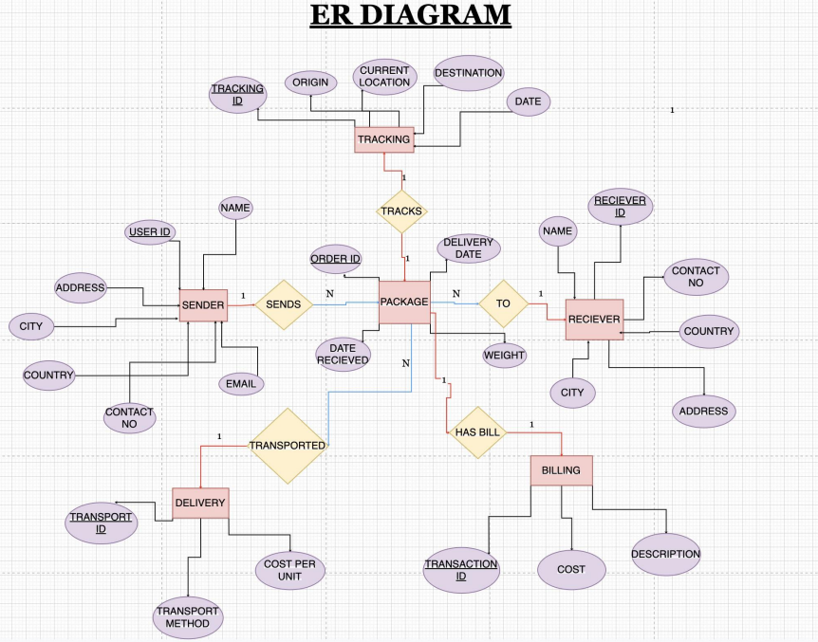

SQL CODE:

